03 Homogeneity Theorem and

Superposition Theorem

1. Fill in the blanks of Table 1 in our class (you can find it from replay), and analyze data from the perspective of homogeneity theorem and superposition theorem.

2．Under what condition does superposition theorem not hold true?

Design an experiment to testify your conclusion.

Note: there are two possibilities

1. we need to change element
2. we don’t need to change element but there may be some other problems with the circuit

*A Report By*

***Kibria Golam***

***ID: 2019380163***

1. Fill in the blanks of Table 1 in our class (you can find it from replay), and analyze data from the perspective of homogeneity theorem and superposition theorem.

1

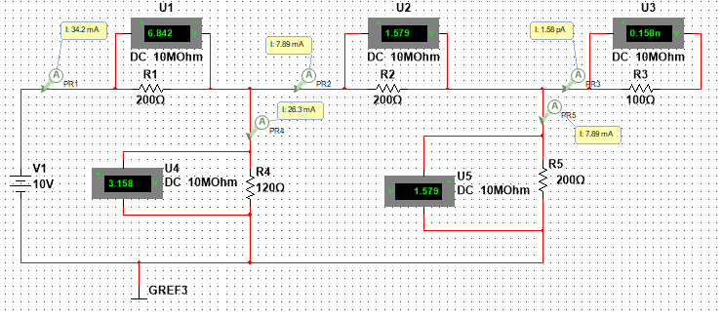

2 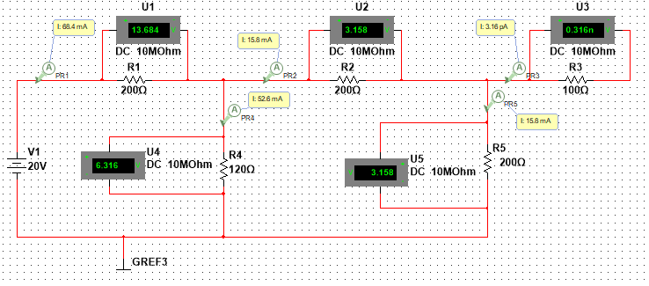

3

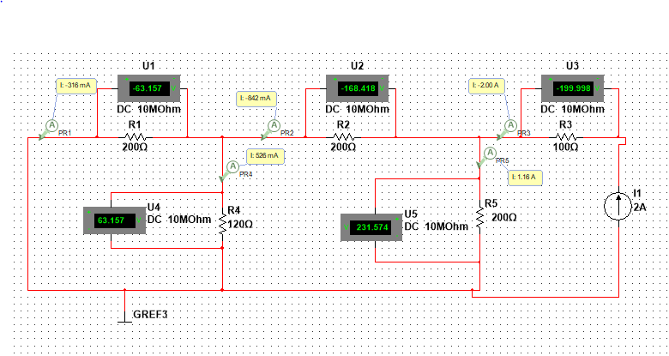

4

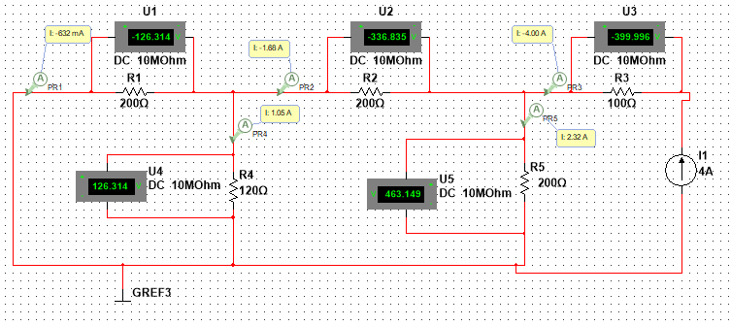

5

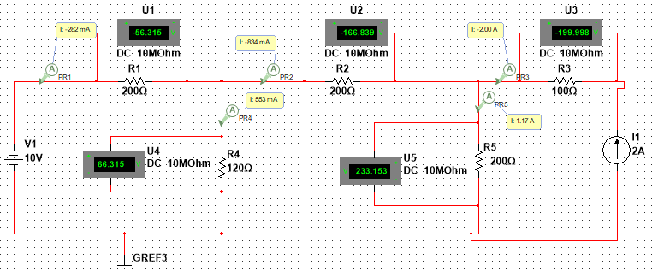

6

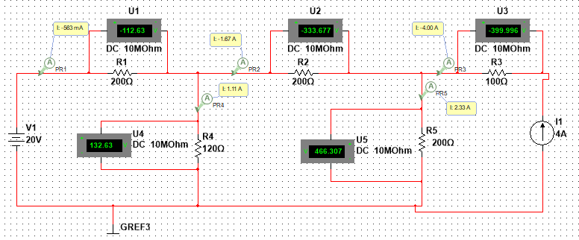

7

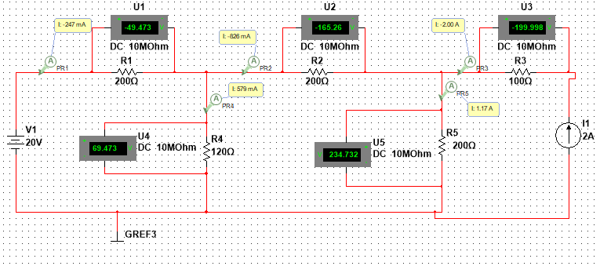

|  |  |  |  |  |  |  |  |  |  |  |  |
| --- | --- | --- | --- | --- | --- | --- | --- | --- | --- | --- | --- |
| Us1 | Is1 | I1 | I2 | I3 | I4 | I5 | UR1 | UR2 | UR3 | UR4 | UR5 |
| 10 | 0 | 34.2 | 7.89 | 7.89 | 26.3 | 7.89 | 6.842 | 1.579 | 0 | 3.158 | 1.579 |
| 20 | 0 | 68.4 | 15.8 | 15.8 | 52.6 | 15.8 | 13.684 | 3.158 | 0 | 6.316 | 3.158 |
| 0 | 2 | -316 | -842 | -2 | 526 | 1.16 | -63.157 | -168.418 | -199.998 | 63.157 | 231.574 |
| 0 | 4 | -632 | -1.68 | -4 | 1.05 | 2.32 | -126.314 | -336.835 | -399.996 | 126.314 | 463.149 |
| 10 | 2 | -282 | -834 | -2 | 553 | 1.17 | -56.315 | -166.839 | -199.998 | 66.315 | 233.153 |
| 20 | 4 | -583 | -1.67 | -4 | 1.11 | 2.33 | -112.63 | -333.677 | -399.996 | 132.63 | 466.307 |
| 20 | 2 | -247 | -826 | -2 | 579 | 1.17 | -49.473 | -165.26 | -199.998 | 69.473 | 234.732 |

From the above data, it is quite evident that when we change the voltage and the current source altogether, the homogeneity theorem holds true. But when we only change the voltage source or the current source the homogeneity theorem doesn't hold true. So, in conclusion, if we want to satisfy the homogeneity theorem, we need to change both sources, not just only one source.

2．Under what condition does superposition theorem not hold true?

Design an experiment to testify your conclusion.

Note: there are two possibilities

Superposition theorem only works in linear circuits. Superposition theorem would not work in nonlinear circuits. Here we have used a diode which is a nonlinear element. From the circuits below we can see If we double the value of the voltage and the current source from 10V and 2A respectively to 20V and 4A, the voltage across the R1 and the diode changes. But no relationship can be found which satisfies the linearity of the circuit.

